# Evaluation and Result

To validate the effectiveness of the designed traffic forecasting system, a demonstration was conducted using a web-based client interface. This interface serves as a proof of concept and can be adapted for end-user applications, such as mobile apps, web browser extensions, or integrations with GPS navigation platforms. The client interface grants access to the user’s geolocation and allows for the creation of a route by specifying either the current location or a different starting point, along with the desired destination.

The system dynamically generates a route based on the real-time traffic situation at the moment of the request, integrating google map API to forecast potential congestion by impementing dijkstra algorithm. The generated route aims to minimize travel time by choosing the optimal path under current and predicted traffic conditions. Initially, the system was trained using a manually set historical dataset to simulate traffic conditions and refine the the routing by digitising some missing network link within the system.

One of the system's key features is its ability to adapt to changing traffic conditions during a trip. If the traffic situation alters while the driver is on the road, the system can recalculate the route in real time to maintain the shortest possible travel time. The accuracy of the forecasts is continually evaluated by comparing predicted traffic conditions with the actual outcomes. This feedback mechanism allows the system to learn and improve its predictive accuracy over time, ultimately enhancing route optimization to achieve reduced travel times and alleviate congestion.

To quantify traffic congestion, the system utilized the condition 14≤ n ≤ 20 for d = 60, where n is the number of vehicles and d represents the length of the road segment under study. This criterion assumes that a traffic jam forms when there are between 14 and 20 vehicles within a 60-meter stretch of road.

Additionally, the system leveraged the Google Maps API to calculate the number of markers (vehicles) in a specific neighborhood of the London road network. This data on inflow and outflow across the network aids in forecasting routes that result in reduced travel times. The application of this system within the London road network, including the University of Roehampton area, demonstrated its potential to optimize routes, thereby contributing to a more efficient transportation system.

To numerically assess the benefits of the designed traffic forecasting system, the system was tested on approximately 10 different routes under varying traffic conditions, including scenarios with different levels of congestion. The evaluation aimed to quantify the time savings achieved by using the forecasting system compared to not using it.

The following metrics were used:

- t1: Time required to complete the route without using the traffic forecasting system.

- t2: Time required to complete the route using the traffic forecasting system.

- Δt: The time difference between completing the route without and with the forecasting system, expressed as a percentage.

Δt = $\frac{t1−t2}{t1}×100$..........................................................................(1)

This formula calculates the percentage of time saved by utilizing the forecasting system. The results from the test routes provided a range of time gains, highlighting the effectiveness of the system in optimizing travel times under different traffic conditions.

Using table 1 which contains the test result of 10 different route by using the forecasting system and without forecasting system. To calculate change of time of travel (Δt) at the minimum fixed gain in time travel within the network by using equation(1),

t1 = 25, t2 = 15

${Δt}_{min}=\frac{t1−t2}{t1}×100$ = $\frac{25−15}{25}×100$

${Δt}_{min}=40\%$......................................................(2)

To calculate change of time of travel (Δt) at the maximum fixed gain in time travel within the network by using equation(1),

t1 = 60, t2 = 45

${Δt}_{max}=\frac{t1−t2}{t1}×100$ = $\frac{60−45}{60}×100$

${Δt}_{max}=25\%$..................................................................(3)

The above calculations demonstrate the efficiency of using the developed system of road traffic forecasting, namely, the following gains in time from 25% to 40% (average values).

|  |  |  |  |
| --- | --- | --- | --- |
| Nodes | Routes | Total Time with Routing System | Total Time without Routing System |
| N1-N2 | Acton- Algate | 20 | 25 |
| N2-N1 | Algate- Acton | 18 | 27 |
| N2-N3 | Algate - Anerly | 45 | 58 |
| N3-N2 | Anerly - Algate | 42 | 60 |
| N3-N4 | Anerly - Balham | 25 | 40 |
| N4-N3 | Balham - Anerly | 23 | 38 |
| N4-N5 | Balham - Battersea | 15 | 30 |
| N5-N4 | Battersea - Balham | 17 | 38 |
| N5-N6 | Battersea - Bayswater | 20 | 30 |
| N6-N5 | Bayswater - Battersea | 18 | 35 |

**Table 1**

In the histogram shown in Fig. 1 presents the time gain for overcoming a route laid without a forecasting system and with a forecasting system (10 routes were considered, while Fig.2 represent the total time gain by using the forecasting system in the 10 test experiment. The obtained results show the expediency of using the designed system for vehicles in urban conditions.

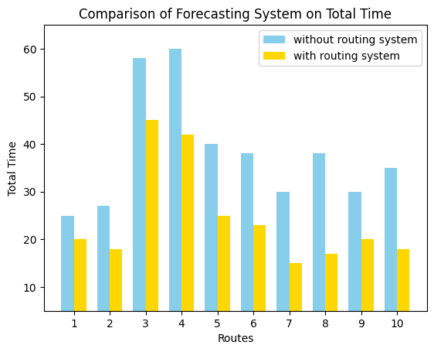

**Fig. 1**

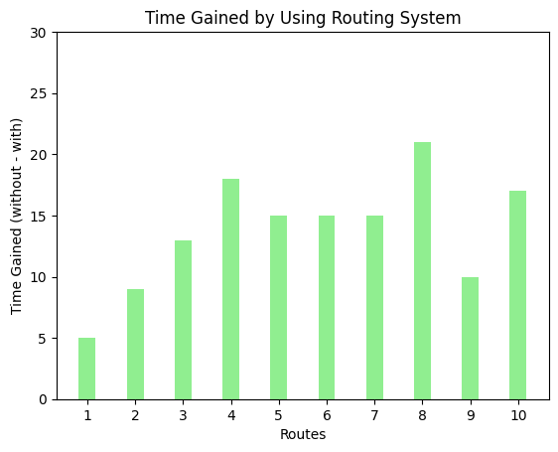

**Fig. 2**

The selected test cases included routes with both minimum and maximum time gains. These cases illustrated the variability in the system's performance, depending on the severity of traffic congestion. In scenarios with heavy congestion, the time savings were more pronounced, demonstrating the system's capacity to significantly reduce travel times by predicting and avoiding traffic jams.

In summary, the evaluation confirmed that the traffic forecasting system consistently provided time savings, with the magnitude of these savings dependent on the traffic conditions encountered on each route. This demonstrates the practical value of the system in real-world applications, offering potential improvements in commute efficiency and reductions in overall travel time.

## 

## 4.1 Related Works

In the domain of traffic forecasting and route optimization, numerous approaches have been proposed to enhance the accuracy and efficiency of transportation systems. A noteworthy contribution is the work by Souad El Houssaini and Abdelmajid Sadri, titled "A Web-Based Spatial Decision Support System for Effective Monitoring and Routing Problem." Their research presents an integrated framework that leverages Geographic Information Systems (GIS) combined with a Relational Database Management System (RDBMS) to improve the monitoring and management of road networks[1] .

El Houssaini and Sadri's system utilizes GIS technology to collect and analyze geographic data related to road networks and monitoring stations. Their framework not only identifies optimal routes based on minimum cost using Dijkstra's algorithm but also supports the strategic placement and orientation of monitoring stations in response to road incidents. The integration of diverse datasets and advanced information retrieval within a GIS environment demonstrates the system's potential to manage complex spatial data and optimize routing decisions effectively.

The effectiveness of their system was tested on the road network of Mohammedia City in Morocco, where it demonstrated significant improvements in response to road accidents through simulated test cases. The proposed system, described as scalable and well-structured, serves as a comprehensive tool for traffic monitoring and routing, particularly in scenarios requiring rapid and efficient intervention.

When compared to the current project on traffic forecasting and route optimization in London and the University of Roehampton, El Houssaini and Sadri's work offers valuable insights into the use of GIS and algorithmic methods for managing and optimizing road networks. While their research focuses on the integration of GIS with RDBMS and the application of Dijkstra's algorithm for routing, the current project builds on these methodologies by incorporating real-time traffic data and Google Maps API. This extension aims to dynamically predict traffic patterns and optimize routes, addressing the specific challenges of London's intricate road network.

Another significant contribution to the field is a study presented at the 1st International Conference of Information Technology to Enhance E-Learning and Other Applications (IT-ELA 2020), hosted by Baghdad College of Economic Sciences University. This study explored the application of parallel computation methods to solve the shortest path problem in vehicular networks [2].

In their paper titled "A Parallel Implementation Method for Solving the Shortest Path Problem for Vehicular Networks," Emad H. Al-Hemiary and Salim A. Mohammed Ali from Al-Nahrain University in Baghdad, Iraq, investigated the complexities of finding the shortest paths in mobile and densely populated vehicular networks. The authors applied Hedetniemi's Algorithm, a well-known method for calculating multi-source multi-destination shortest paths, and enhanced its computational efficiency using OpenCL (Open Compute Language).

Their research demonstrated a substantial acceleration in path calculation, achieving a 40x speedup when utilizing parallel computation compared to a sequential approach. This acceleration was particularly evident when handling high-dimensional input data, making the system more responsive and scalable for real-world applications. This study highlights the importance of leveraging parallel computing techniques to address the computational challenges inherent in vehicular networks, a goal that aligns closely with the objectives of the traffic forecasting system developed in the current research.

These related works underscore the ongoing advancements in traffic management and the potential of integrating advanced computation methods and real-time data to further optimize route planning systems. Such innovations contribute significantly to the overall efficiency and responsiveness of modern transportation networks.

References

1. S. E. Houssaini and A. Sadri, "A web-based spatial decision support system for effective monitoring and routing problem," in Proc. of the International Conference on Geographic Information Systems (GIS), Mohammedia, Morocco, 2023, pp. 1-6.

[2] E. H. Al-Hemiary and S. A. Mohammed Ali, "A Parallel Implementation Method for Solving the Shortest Path Problem for Vehicular Networks," in Proc. 1st Int. Conf. Inf. Technol. Enhance E-Learning Other Appl. (IT-ELA 2020), Baghdad College of Economic Sciences University, Baghdad, Iraq, 2020, pp. 1-6.